Application Gateway

Azure Application Gateway gives you application-level routing and load balancing services that let you build a scalable and highly-available web front end in Azure. You control the size of the gateway and scale your deployment based on your needs.

https://learn.microsoft.com/en-us/azure/application-gateway/overview

HW
https://azure.microsoft.com/en-gb/products/application-gateway/

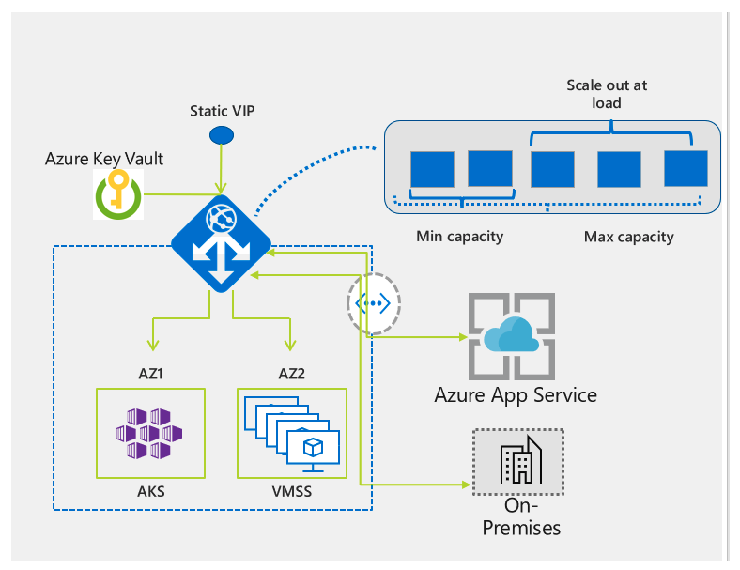

How to configure Application Gateway

- Need min 2 VMs to load balance and Appgateway
- Install apache2 on both the VMs and configure websites
- Both websites should be accessible using public IPs
- Create Application Gateway
- Configure Backend pools
- Configure Health Probe
- Check the Backend health

